Name: Tasneem
prn:23070521162
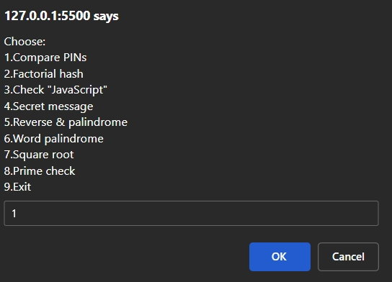

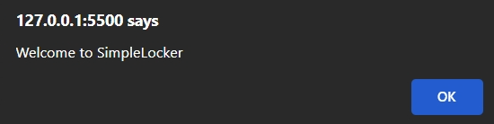
<!DOCTYPE html>
<html>
<head><title>Simple Digital Locker Menu</title></head>
<body>
<script>
// Global variable (scope demo)
let lockerName = "SimpleLocker";

// 1. Compare two PINs
const getGreater = (a, b) =>
isNaN(a) || isNaN(b) ? "Error: Invalid numbers" : (a > b ? a : b);

// 2. Factorial - function expression
const factorial = function(n) {
if (isNaN(n) || n < 0) return "Error: Invalid number.";
let f = 1;
for (let i = 2; i <= n; i++) f *= i;
return f;
};

// 3. Arrow function to check "JavaScript" presence
const checkScript = str => str && str.toLowerCase().includes("javascript");

// 4. Closure to store secret message
function secureMessage(pass) {
let secret = "";
return (tryPass, msg) => tryPass === pass ? (msg || secret) && (secret = msg || secret) : "Access Denied";
}

// 5. Reverse number with error handling
function reverseNumber(num) {
try {
if (typeof num !== "number" || isNaN(num)) throw "Invalid Input";
let revStr = Math.abs(num).toString().split("").reverse().join("");
return parseInt(revStr) * Math.sign(num);
} catch (e) {
return "Error: Invalid number";
}
}

// 6. Palindrome check for numbers
function isPalindrome(num) {
let str = Math.abs(num).toString();
return str === str.split("").reverse().join("");
}

// 7. Palindrome check for words
function isWordPalindrome(word) {
if (!word) return false;
let cleaned = word.toLowerCase().replace(/\s/g, '');
return cleaned === cleaned.split('').reverse().join('');
}

// 8. Square root with error handling
function sqrtSafe(num) {
try {
if (typeof num !== "number" || isNaN(num)) throw "Invalid Input";
if (num < 0) throw "Negative number not allowed";
return Math.sqrt(num).toFixed(3);
} catch (e) {
return "Error: " + e;
}
}

// 9. Prime check arrow function
const isPrime = num => {
num = parseInt(num);
if (isNaN(num) || num < 2) return false;
for (let i = 2; i <= Math.sqrt(num); i++)
if (num % i === 0) return false;
return true;
};

function showMenu() {
alert("Welcome to " + lockerName);
const vault = secureMessage("lock123");

while (true) {
let choice = prompt(`Choose:
1.Compare PINs
2.Factorial hash
3.Check "JavaScript"
4.Secret message
5.Reverse & palindrome
6.Word palindrome
7.Square root
8.Prime check
9.Exit`);
if (!choice) continue;
if (choice === "9") break;

switch(choice.trim()) {
case "1": {
let a = Number(prompt("First PIN:"));
let b = Number(prompt("Second PIN:"));
alert("Stronger PIN: " + getGreater(a, b));
break;
}
case "2": {
let n = Number(prompt("Number for factorial:"));
alert("Factorial: " + factorial(n));
break;
}
case "3": {
let msg = prompt("Enter message:");
alert(checkScript(msg) ? "Contains 'JavaScript'" : "No 'JavaScript'");
break;
}
case "4": {
let p = prompt("Vault password:");
let m = prompt("Secret message (blank to view):");
alert(vault(p, m ? m : undefined));
break;
}
case "5": {
let num = Number(prompt("Number to reverse:"));
let rev = reverseNumber(num);
alert(typeof rev === "number" ? `Reversed: ${rev}\nPalindrome? ${isPalindrome(rev) ? "Yes" : "No"}` : rev);
break;
}
case "6": {
let w = prompt("Word or phrase:");
alert(isWordPalindrome(w) ? "Palindrome" : "Not palindrome");
break;
}
case "7": {
let val = Number(prompt("Number for sqrt:"));
alert("Square root: " + sqrtSafe(val));
break;
}
case "8": {
let v = prompt("Number to check prime:");
let res = isPrime(v);
alert(res === true ? "Prime" : res===false ? "Not prime" : res);
break;
}
default:
alert("Invalid option");
}
}
}
showMenu();
</script>
</body>
</html>

